Real-Time / Streaming Analysis

Definition
# Source: AI Source: Provided by: [Data Path: Persons Table -> ID Column: 1, Name_En Column: Motasem Essam] -> From: [Chatgpt (GPT‑5 Mini)] on [12/10/2025]
Real-Time / Streaming Analysis is the process of analyzing data immediately as it is generated to provide instant insights or actions.
- Often used in sensor monitoring, financial trading, social media tracking, or IoT applications.
- Allows organizations to react quickly to changing conditions.
Key idea:
It’s like monitoring live traffic cameras to adjust signals instantly rather than waiting until the end of the day to review traffic patterns.

Characteristics of Real-Time / Streaming Analysis
# Source: AI Source: Provided by: [Data Path: Persons Table -> ID Column: 1, Name_En Column: Motasem Essam] -> From: [Chatgpt (GPT‑5 Mini)] on [12/10/2025]
- Processes data continuously instead of in batches
- Requires low-latency systems to handle incoming streams quickly
- Often uses message queues, streaming platforms (e.g., Apache Kafka), and in-memory processing
- Can trigger alerts, automated actions, or dashboards instantly
- Works best for time-sensitive decisions and monitoring

Examples
# Source: AI Source: Provided by: [Data Path: Persons Table -> ID Column: 1, Name_En Column: Motasem Essam] -> From: [Chatgpt (GPT‑5 Mini)] on [12/10/2025]
- Financial Trading: Analyze stock prices in real time to execute trades automatically.
- IoT Sensors: Monitor temperature, pressure, or machinery in a factory and trigger alerts for anomalies.
- Social Media Monitoring: Track hashtags or mentions in real time to respond to trends or crises.
- Website Analytics: Monitor website clicks or user activity live to adjust marketing campaigns.
- Smart City Traffic Control: Adjust traffic lights based on live vehicle flow data.

Advantages
# Source: AI Source: Provided by: [Data Path: Persons Table -> ID Column: 1, Name_En Column: Motasem Essam] -> From: [Chatgpt (GPT‑5 Mini)] on [12/10/2025]
- Provides instant insights for immediate decision-making
- Detects anomalies or issues quickly, preventing potential problems
- Supports automation, reducing manual intervention
- Enhances real-time monitoring, alerts, and predictive maintenance
- Helps organizations respond to opportunities or threats immediately

Disadvantages
# Source: AI Source: Provided by: [Data Path: Persons Table -> ID Column: 1, Name_En Column: Motasem Essam] -> From: [Chatgpt (GPT‑5 Mini)] on [12/10/2025]
- Requires specialized tools and infrastructure for streaming and processing
- Can be computationally intensive, especially with large volumes of data
- Complex to design, maintain, and scale compared to batch analysis
- Errors in live data can lead to wrong automated decisions if not monitored carefully
- May require constant monitoring and updates to handle changing data patterns

Example Section
# Source: AI Source: Provided by: [Data Path: Persons Table -> ID Column: 1, Name_En Column: Motasem Essam] -> From: [Chatgpt (GPT‑5 Mini)] on [12/10/2025]
A smart factory monitors temperature and vibration sensors on machines in real time:
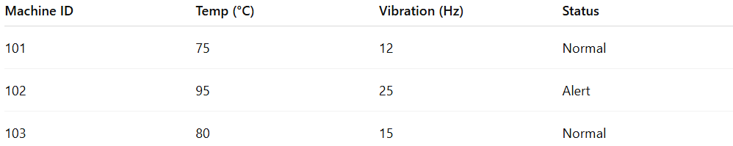
Machine ID | Temp (°C) | Vibration (Hz) | Status
101 | 75 | 12 | Normal
102 | 95 | 25 | Alert
103 | 80 | 15 | Normal
Analysis:
- Machine 102 exceeds safe temperature and vibration limits.
- Real-time system triggers an automatic alert to technicians.
- Maintenance can act immediately, preventing potential breakdowns.
- Factory avoids downtime and costly repairs.

